**SERB SPONSORED Three-Days WORKSHOP ON**

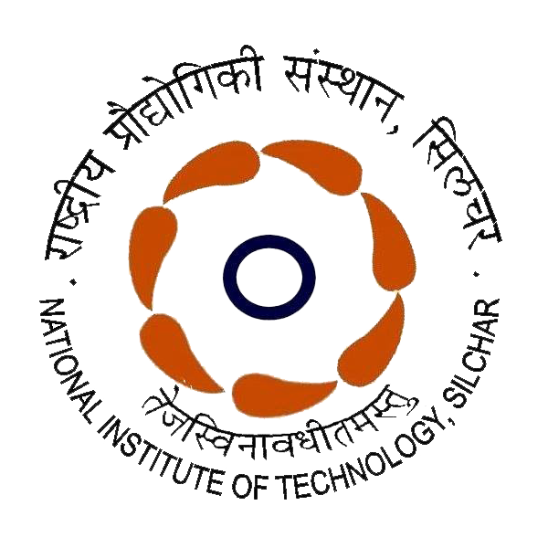**Recent Advancements in Pico Hydro Technologies**

**(RAPHT-2025)**

(Under the SSR Scheme - A SERB Initiative)

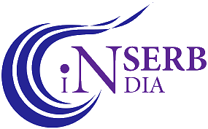

**3 - 5 February 2025**

**National Institute of Technology Silchar, Assam**

**Registration:**

* Use the below link for application.
* Plan journey only after confirmation email.

**https://forms.gle/dEF4iF9a8WSBDLaMA**

**Introduction to Workshop:** This program aims to provide opportunities to faculty and UG/PG/PhD students from universities and colleges to get exposure and hands-on research skill development experience in zero-head pico-scale hydropower technologies. It attempts to bring forth the modern techniques and practices in pico-scale hydro technologies. It is hoped that this workshop will setup a common platform for collaboration among the researchers, scholars, educationists, and faculty of various departments and institutes.

**Dept. of ME:** With the academic activities starting in 1977, the Department is one of the oldest and finest in the zone. From the very onset, the main objective of the department is to strengthen the academic and technical knowledge of the students through various world-class technologies, teaching-learning, and research activities. The department offers 04 years B. Tech. in Mechanical Engineering, 02 years M. Tech for five PG courses. The deptt. always keep itself up to date with the latest technological developments with a dedicated faculty of highly qualified and experienced members.

**NIT Silchar:** The National Institute of Technology (NIT) Silchar, Assam was established in 1967 as a regional engineering college. It attained the prestigious status of NIT in 2002 and the status of institute of national importance in 2007. NIT Silchar offers undergraduate, post- graduate, and doctoral programs in engineering, science, humanities, and management, catering to nearly 5000 students. The institute’s sprawling campus of around 625 acres is equipped with state-of-the-art infrastructure and surrounded by lush greenery.

**Flight : Kumbhirgram - Silchar Airport (IXS), 25 km.**

**Train : Silchar (SCL), 10 km; Badarpur (BPB), 25 km.**

**Bus : ISBT Silchar, 10 km.**

**About Workshop:** This workshop is being organized under the social scientific scheme (SSR) of SERB-CRG project. SSR is an effort to improve research productivity and skill development of promising PhD, PG and senior UG students from institutes, universities and colleges across the country through high-end workshops funded under the SSR scheme of SERB, Govt. of India. Dissemination of science and creating awareness is the focus of the workshop, which will help communicate research outputs to the general public.

**Resource Persons:**

* Faculties from IITs, NITs, and other top academic institutes.
* Professionals from Industry.

**Participation Criteria:**

* Open to PhD, PG, and final year B.Tech. students.
* Affiliation - Any institute in India.
* Maximum 35 seats.

**Chief Patron:**

Prof. Dilip Kumar Baidya, Director, NIT Silchar

**Patron:**

Prof. Nalin B. D. Choudhury,

Dean Research & Consultancy, NIT Silchar

**Organizing Chair:**

Head of the Department, Mechanical Engg.

**Workshop Coordinators:**

* Prof. R.D. Misra

[rdmisra@mech.nits.ac.in,](mailto:koena@ei.nits.ac.in) 9435072301

* Dr. A. Biswas

[agnibis@mech.nits.ac.in,](mailto:koena@ei.nits.ac.in) 9435500659

**Members:**

All faculty members of ME Deptt., NIT Silchar

**SERB Support & Financial obligations:**

* Registration fee waived-off.
* TA/DA to be borned by the participants
* Lodging and Boarding as per standard norms in the NIT Silchar guest house or scholars hostel on payment basis.
* Completion certificate.

**Workshop Topics (Theory & Hands-on):**

* Ultra-low or zero head pico-scale hydro turbines
* Design and performance of pico-scale hydro turbines
* Experimental approaches for performance investigations
* CFD approaches for performance investigations
* Hands on training on operation and exposures on pico-scale turbines
* Societal impacts on harvesting pico-scale hydro power
* Entrepreneurship and start-up opportunities